“Parents and schools need to help children to learn to use technology in good, appropriate way.”  9 THEMES TO SUCCESSFUL USE OF TECHNOLGY  - DIGITAL ACCESS  - DIGITAL COMMERCE  - DIGITAL COMMUNICATION  - DIGITAL LITERACY  - DIGITAL ETIQUETTE  - DIGITAL LAW  - DIGITAL RIGHTS AND RESPONSABILITIES  - DIGITAL HEALTH AND WELLNESS  - DIGITAL SECURITY (SELF PROTECTION) |  |  | WHY IS IT IMPORTANT TO KNOW THESE 9 THEMES?  What do children need to know about technology?  How to participate in society, how to buy or sell products online, how to communicate, how to understand its use, where it is appropriate, what is illegal, how to handle cyber bullying, time management with technological devices, and the proper use of virus protectors.  How to implement these themes into their lives?  We need to determine appropriate use for technology for our child at home and at school. We need to implement a healthy balance between technology and all other activities. We need to make sure our children know technology’s uses in society. We as teachers and parents are responsible for our children’s growth in technology.  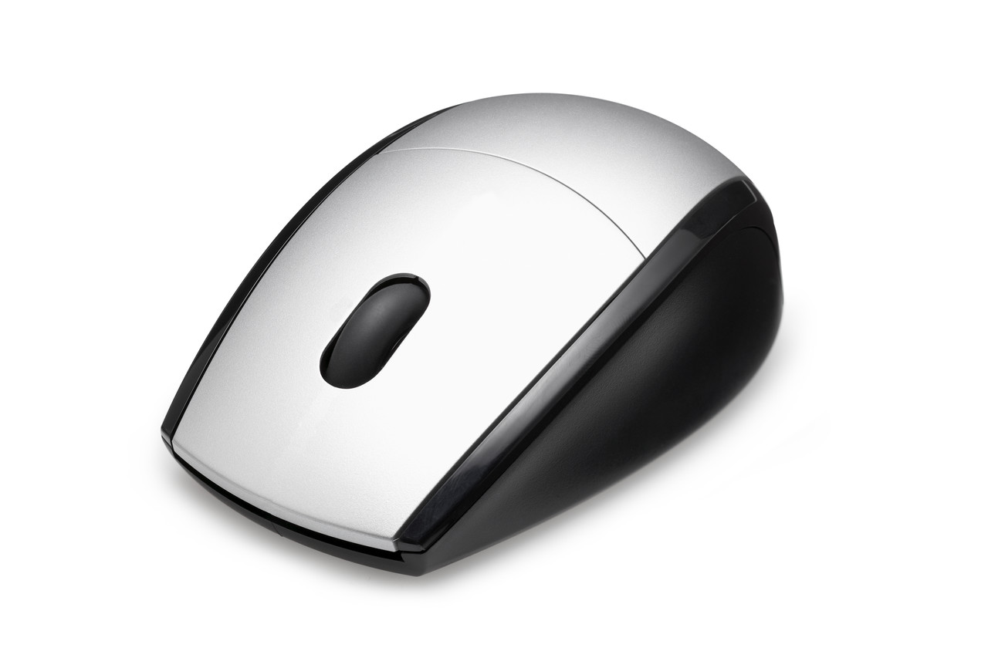 RAISING A dIGITAL cHILD Kids & Education www.awaymagazin.be www.digitalcitizenship.org |  |  | 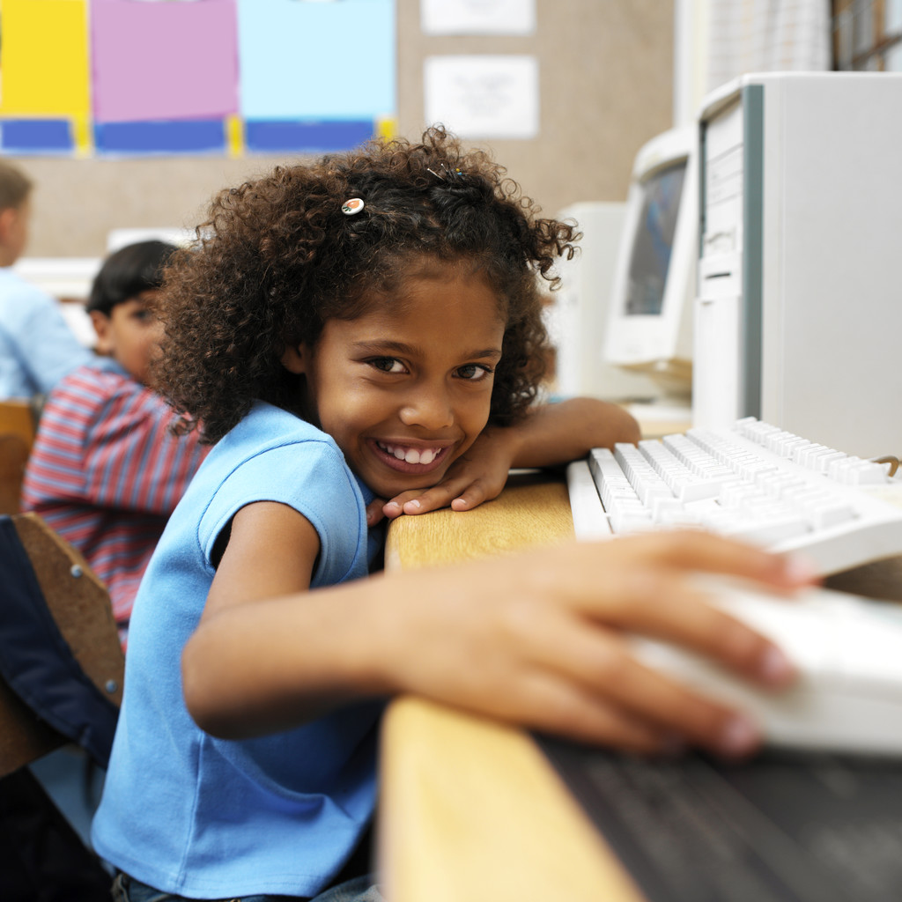  RAISING A dIGITAL cHILD  - 9 THEMES TO CONSIDER

WHAT CAN WE DO?  - ALLOW OUR CHILDREN TIME TO USE TECHNOLOGY UNDER OUR SUPERVISION  - TEACH OUR CHILDREN SECURE SITES AND APPLY PARENTAL CODES TO TECHNOLOGICAL DEVICES  - TEACH OUR CHILDREN THE PROPER USE OF CELLPHONES  - PROVIDE RULES FOR WHERE THEY ARE ALLOWED TO USE TECHNOLOGY DEVICES  - TEACH OUR CHILDREN HOW TO USE TECHNOLOGICAL DEVICES  - ENPHASIZE THE RULES OF THE INTRANET  - WARN OUR CHILDREN ABOUT CYBER BULLYING  - LIMIT THE TIME OUR CHILDREN ARE ON TECHNOLOGICAL DEVICES  - PUT VIRUS PROTECTORS ON OUR CHILD’S TECHNOLOGICAL DEVICES. |  |  | WHAT ARE SOME FORMS OF TECHNOLOGY CHILDREN WILL USE?  - PHONES, COMPUTERS, IPADS, TABLETS, LAB TOPS, TVS, GAME SYSTEMS, IPODS, KINDLES, ECT.  BRINGING UP CHILDREN CAN BE DIFFICULT AT THE BEST OF TIMES, BUT IT SEEMS THAT TECHNOLOGICAL ADVANCES ARE ADDING TO THE PRESSURES, WRITES DR. MIKE RIBBLE.  FROM MRS. HARPER’S CLASS TO YOUR HOME, LET TECHNOLOGY BE KNOWN! |  |  | 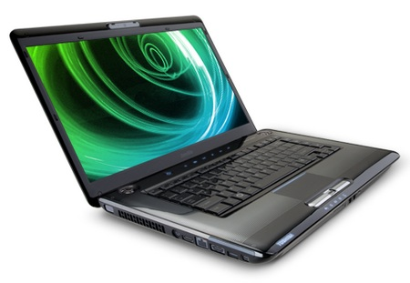  “IT CAN SEEM OVERWHELMING FOR PARENTS AND EDUCATORS WHO FEEL THEY CANNOT KEEP UP WITH THE RAPID CHANGES OF A TECHNOLOGICAL WORLD.”  LET’S ENCOURAGE THEM TO USE TECHNOLOGY!

